ShopNow Customer Segmentation Using K-Means
Eugenie Lai Mar. 2, 2026

1. Dataset Overview
The dataset contains:
Metric | Value
Number of Customers | 6,000
Total Variables | 19
Segmentation Variables Used | 9 (RFM + Category Share)
Clustering Method | KMeans
Final Number of Clusters | 4

2. Segmentation Input Preparation
Selected Variables:
RFM Behavioral Variables
Variable | Meaning
recency_days | Days since last purchase
orders_last_12m | Number of orders in past 12 months
avg_order_value | Average spending per order
Category Share Variables
Variable Type | Description
cat_share_* | Share of total spend by product category (electronics, apparel, home, beauty, groceries, sports)
Data Preparation Steps
Step | Action | Reason
Infinity handling | Replaced ±inf with NaN | Prevents numerical instability
Missing values | Filled with median | Robust, keeps all customers
Scaling | StandardScaler on RFM only | Prevents large-scale variables from dominating
Category share | Left unscaled | Already 0–1 scale, interpretable

3. Elbow Method Results
The elbow curve (k=2 to k=10) showed diminishing improvements after k=4, indicating that four clusters provide a good balance between compactness and interpretability.
k | Observation
2–3 | Large drop in WCSS
4 | Noticeable bend (elbow)
5–10 | Gradual, smaller improvements
Final Selection: k = 4
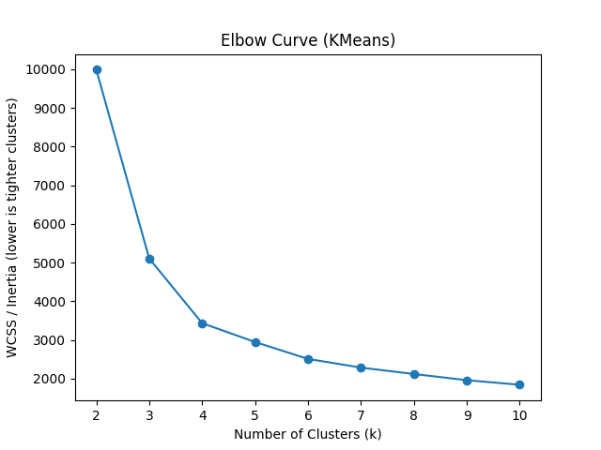
4. Final Cluster Distribution
Cluster | Customers | % of Total
0 | 1,536 | 25.6%
1 | 1,902 | 31.7%
2 | 1,350 | 22.5%
3 | 1,212 | 20.2%
Clusters are reasonably balanced, suggesting meaningful segmentation rather than artificial splits.

5. Cluster Profile (Mean Values)
Cluster | Recency (days) | Orders (12m) | Avg Order ($) | Electronics | Apparel | Home | Beauty | Groceries | Sports
0 | 549.67 | 1.00 | 29.90 | 0.164 | 0.166 | 0.166 | 0.169 | 0.165 | 0.168
1 | 93.17 | 5.64 | 71.29 | 0.170 | 0.169 | 0.164 | 0.162 | 0.166 | 0.170
2 | 79.60 | 4.00 | 205.43 | 0.175 | 0.166 | 0.165 | 0.169 | 0.164 | 0.161
3 | 57.11 | 11.62 | 45.67 | 0.175 | 0.176 | 0.161 | 0.164 | 0.166 | 0.159

6. Segment Interpretation
Cluster 3 — High Frequency Loyal
- Lowest recency
- Highest order frequency
- Strong engagement
Marketing Strategy: retention rewards, referral programs, exclusive promotions.
Cluster 2 — Big Spenders
- Highest average order value
- Moderate purchase frequency
- Premium-value customers
Marketing Strategy: VIP offers, premium bundles, personalized upsells.
Cluster 1 — Mid-tier Regulars
- Moderate recency and frequency
- Mid-level spending
Marketing Strategy: frequency boosters (bundles, subscription incentives).
Cluster 0 — Inactive / Churned
- Extremely high recency (~550 days)
- Minimal orders
- Low spending
Marketing Strategy: reactivation campaigns, limited-time discounts, churn surveys.

7. Key Analytical Insight
Although category shares were included, segmentation is primarily driven by RFM behavior rather than strong differences in product mix.
This suggests that customer value and engagement matter more than product preference differences in defining customer segments at ShopNow.

